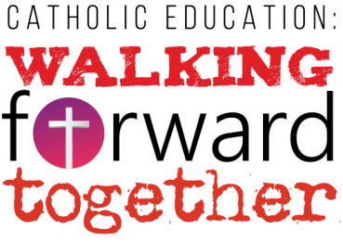

Music Monday – May 2, 2017

This year’s Catholic Education Week theme is, “Walking Forward Together.”

The 2017 CEW theme and its five sub-themes are drawn from three contemporary Catholic documents that address the need for reconciliation and renewal – in our lives, with our families, in our relationships with others and in our relationship with our environment and our common global future.

There are five sub-themes for each day of Catholic Education Week:

Day 1: Walking Forward Together with God
Aller de l’avant avec Dieu
Day 2: Walking Forward Together with Our Families
Aller de l’avant avec nos familles
Day 3: Walking Forward Together with Others
Aller de l’avant avec les autres
Day 4: Walking Forward Together with Creation
Aller de l’avant avec la Création
Day 5: Walking Forward Together in Hope
Aller de l’avant dans l’espérance

Every year, the Ontario Catholic School Trustees’ Association (OCSTA) provides our Catholic schools with a resource kit to help schools prepare for Catholic Education Week. Our teachers now have these resource kits and are preparing their plans for their students.
Here at St. Patrick we will commence our Catholic Education Week with a Celebration performed by the students from Grades 4 to Grade 8.

Parents and caregivers of students from grades 4 to 8 are invited to attend the performance:

Time: 1:30 pm
Location: School Gym

Please note the following requirements while attending:

- St. Patrick students will already have seen the concert in the morning. Therefore, older siblings will not be invited to watch the 1:30 performance with their families. Please do not ask to withdraw your child to watch the performance.
- Due to fire regulations and limited space in the gym, we cannot accommodate strollers into the building.
- The audience is to remain seated during ALL performances as the entire length is less than 1 hour.
- The school day will continue throughout the performance. Parents and guardians are asked to make their way immediately to the gymnasium and refrain from gathering in the front lobby or walking around the school.
- Once the performance is over all the students will make their way to their classrooms. The end of the day is a busy time for the office. Therefore, parents wishing to take their children home earlier, may do so RIGHT AFTER THE END OF THE PERFORMANCE, which should be at approx. 2:30 pm.

