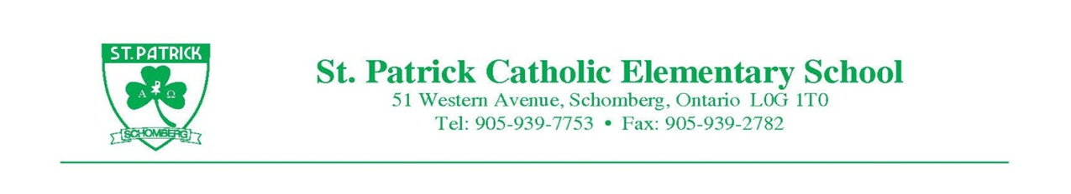
Thursday November 2, 2017
Dear Parents/Guardians;
Popcorn Fridays are coming to St. Patrick! Beginning Friday November 9th, we will be selling Foodland Ontario Popcorn from 11:45 am - 12:05 pm. “Butter-Salt” and “White Cheddar” flavors will be available for purchase. The popcorn sold is peanut free and gluten free and made in a nut-free environment. The popcorn does contain milk and milk proteins. The ingredients are listed below for your review:
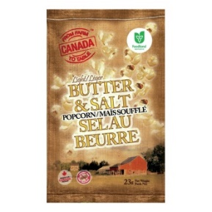
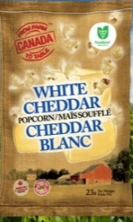

Ingredients (“Butter & Salt” flavour): whole grain corn, canola oil, natural flavour (milk), beta carotene.

Ingredients (“White Cheddar” flavour): whole grain corn, canola oil, white cheddar seasoning (sunflower oil, modified milk ingredients, maltodextrin, salt, natural flavour (contains milk), potassium chloride, cheddar cheese (contains milk), sugar, silicon dioxide, disodium Phosphate, lactic acid, calcium lactate, citric acid.

Bags will be sold for $2.00 each. Proceeds from the sales will go to support school events and/or initiatives, such as the 50th Anniversary of St. Patrick C.E.S.

So POP open the piggy banks and POP on over to the office for a healthy and POPular snack!

Thank you for your support!
T. Tata
Principal

